Aug 12 (Monday): Day -1: Toronto to Visalia

Fly YYZ (8 am) > LAX (10:06 am)

Travel to bus station

Greyhound Bus LA 2:45 PM > Visalia 7:20 PM

Greyhound confirmation number: 35739496

Stay: LAMP LITER INN Aug 12

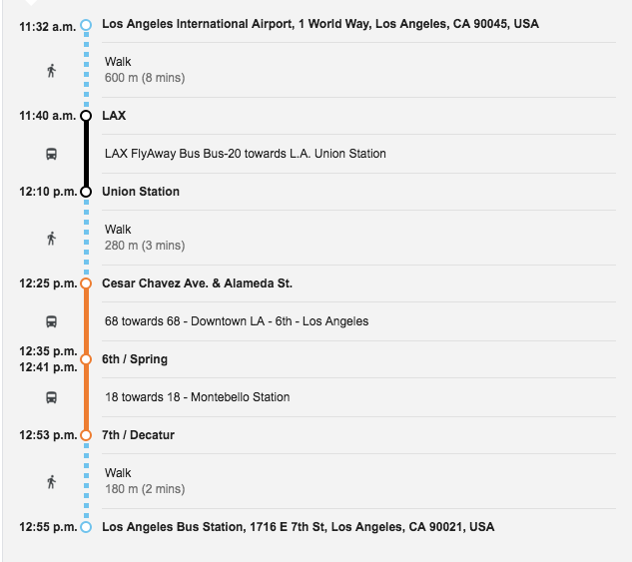

Aug 13: Day 0: Visalia to Dorst Campground

Sequoia Shuttle: 10:10 AM > Giant Forest Museum (12:45 pm) > Lodgepole Visitor’s Centre

Pick up permits at Lodgepole Visitor’s Centre (Open until 3:00pm)

Sequoia Internal Park Shuttle to Dorst Campground

Stay: Dorst Campground Aug 13

Reservation Information

Order #: 0186147964

Tue, Aug 13, 2019

Check-In: 12:00 PM

Wed, Aug 14, 2019

Check-Out: 12:00 PM

#096, Loop D

Dorst Creek Campground, Sequoia And Kings Canyon National Park

Aug 14: Day 1: Dorst Campground to Nine Mile Creek

Free Park Shuttle 8 am > Crescent Meadow Trailhead

Crescent Meadow > Nine Mile Creek

You have been awarded your reservation for a wilderness permit in Sequoia and Kings Canyon National Parks for the following:

Permit Number: 19-01443

# of People in Party: 2

Entry Date: 08/14/2019

Entry Trail: High Sierra Trail

Exit Date: 08/21/2019

Exit Trail: Trail Crest/Main Whitney

Pay.Gov Receipt

Tracking Information

Pay.gov Tracking ID: 26GCH826

Agency Tracking ID: 75711949375

3/27/2019 Pay.gov - Receipt

Transaction Date: 03/27/2019 11:06:17 AM EDT Payment Date: 03/27/2019

PERMIT NUMBER: 19-01443

High Sierra Trail Itinerary: <https://www.jmpeltier.com/2018/07/27/high-sierra-trail-itinerary/>

Crescent Meadow to Nine Mile Creek – 8.8 miles, 1,410′ ascent

Start the hike at Crescent Meadow and backpack to Nine Mile Creek. You’ll be on the south-facing side of the valley in which the Middle Fork of the Kaweah River runs through. Much of the trail is shaded, but it can still get very hot due to its south-facing aspect.

The first three miles are fairly dry, but there are numerous spring and creek crossings over the final six miles. You’ll enjoy great views of Sugarbowl Dome, Little Blue Dome, and Castle Rocks.

Nine Mile Creek campsite: There are a couple of sites near the bear box right on the trail. Another hidden spot lies to the north of the trail, and there are a couple other spots down the hill to the south. Nine Mile Creek is immediately east of the campsite and offers a few semi-secluded swimming holes. This campsite is very wooded and can get buggy.

Alternate campsites:

Mehrten Creek: ~6 miles, about a half-dozen sites, bear box, water, slightly exposed, views.

Buck Creek: ~9 miles, only a few sites, bear box, water, slightly exposed, in a scenic canyon.

Bearpaw Meadow: 11.4 miles, numerous sites, small spring, wooded with nearby great views.

nine mile creek.

Aug 15: Day 2: Nine Mile Creek to Hamilton Lake – 6.9 miles, 1,760′ ascent

From Nine Mile Creek you’ll immediately descend down into Buck Canyon, where you can find some backup campsites if Nine Mile is full. Then you’ll climb out of the canyon and hit Bearpaw Meadow, which is another common first-night campsite. You’re now on the south face of another valley, this one surrounding Hamilton Creek. This trail is also exposed and can get hot; an early departure is recommended. The final climb from the waterfalls up to Hamilton Lake can exhaust many people.

Big Hamilton Lake campsite: There are numerous campsites spread out along the northwest side of the lake, which is backdropped by gorgeous granite cliffs and two waterfalls. Be sure to check in the crags south of the big granite slab; there are a few other sites back here. There are two bear boxes at Hamilton Lake and also a pit toilet. The pit toilet is more or less useless and overflowing as of July 2018. No campfires.

Alternate campsite:

Precipice Lake: ~9.9 miles, 3,760′ ascent, a few exposed sites, above the treeline, spectacular views. Only attempt to continue here if it’s not too hot and you’ve got plenty of juice left. This very unique lake has a few sites on the west and north side. No campfires.

Dinner at Hamilton Lake

Aug 16: Day 3: Hamilton Lake to Big Arroyo Junction – 7.9 miles, 2,570′ ascent

The climb out of Hamilton Lake is best done early in the morning before the sun hits the north wall; this’ll keep it cooler and is also beautiful. You’ll soon find yourself above the rock formation known as Valhalla (which you were staring at from below the previous day). There are some great wildflower shows and numerous creeks during the climb out. This section of the High Sierra Trail also features the tunnel that was blasted through the canyon wall after a steel bridge was destroyed in 1937. You’ll reach Precipice Lake, cross over Kaweah Gap and the Great Western Divide, then descend the Nine Lakes Basin to Big Arroyo Junction. There are plenty of water sources after the pass.

Big Arroyo Junction campsite: This campsite has numerous spots near Big Arroyo Creek; they’re all spread out and most provide shelter. There is one bear box here. This was one of the worst mosquito experiences of the trip but there aren’t a lot of other options.

Alternate campsites: There is one campsite suitable for a couple tents about a half-mile prior to reaching Big Arroyo Junction; you’ll see this on the right side. Near a small creek and sheltered in woods.

Moraine Lake: ~14.7 miles, 3,790′ ascent, sheltered, scenic lake. Long hike topped off by an exposed final section that can get hot while climbing up to the Chagoopa Plateau.

big arroyo junction

Camping at Big Arroyo Junction

Aug 17: Day 4: Big Arroyo Junction to Kern Hot Springs – 13.9 miles, 1,250′ ascent (3,900′ descent)

The climb out of Big Arroyo Junction is a pleasing, long, steady 1,000′ ascent to the Chagoopa Plateau. The descent takes you back down this scenic plateau; at almost five miles you can take a detour to Moraine Lake or continue north around the lake to Kern Canyon. The plateau rapidly starts to drop off approaching the canyon and in no time you’ll be descending almost 4,000′ from the highest point of the plateau. From the bottom of the trail, it’s two miles through shale and riparian forest to Kern Hot Springs.

Kern Hot Springs campsite: This is one of the largest campsites along the High Sierra Trail. The northernmost spots have water access at Rock Creek, the rest are better off getting water from the Kern River. There is also a hot spring at this site, as the name implies. Use the concrete tub that fills from the smaller hot spring above. It’s next to Kern River. Going between the cold river water and hot spring water will recharge your tired feet. There are two bear boxes at Kern Hot Springs and one newer pit toilet in excellent condition (it’s really just a wooden platform over a hole in the ground with a toilet seat, and a waist-high wooden fence for privacy).

Alternate campsites:

Moraine Lake: ~7.3 miles, 1,100′ ascent, water, scenic lake, wooded.

Upper Funston Meadow: ~12 miles, water, wooded, buggy.

Kern Hot Springs

Aug 18: Day 5: Kern Springs to Wallace Creek – 12.4 miles, 3,600′ ascent

Despite being shorter than the previous day, this day will feel longer thanks to the altitude gain. The first eight miles are shaded and scenic as the High Sierra Trail gradually climbs along the Kern River and bottom of Kern Canyon. There are numerous stream crossings, some of which can be quite tricky and may require changing footwear if you brought it. Upon reaching Junction Meadow, the trail quickly climbs out of the canyon and up Wallace Creek. You’ll get some great views down Kern Canyon to the south, and the Kaweah Peaks and Kern Kaweah River Falls to the west.

If you camp at Kern Hot Springs, Wallace Creek is probably the best place to stay for an easy half-day to Guitar Lake. If you camp at Junction Meadow this night or the next, you may want to skip Wallace Creek and proceed to Crabtree Meadow the following night.

Wallace Creek campsite: The High Sierra Trail joins up with both the Pacific Crest Trail and John Muir Trail at Wallace Creek. This means that the established campsites can quickly fill up, especially if you get there late. There are still, however, plenty of sites spread out throughout the area. There is one bear box and easy water access. The campsite is semi-wooded but the high elevation can make some sites exposed. No campfires.

Alternate campsites:

Junction Meadow: 7.7 miles, 1,100′ ascent, water, wooded, bear box, buggy.

Crabtree Meadow: 16.4 miles, 4,200′ ascent, water, wooded, ranger station. No campfires.

Campsite at Wallace Creek

Aug 19: Day 6: Wallace Creek to Guitar Lake – 6.8 miles, 1,530′ ascent

The hike from Wallace Creek to Guitar Lake is a simple 6.8-mile jaunt, a nice break from the past couple days of 12-13 miles and tall ascents. You’ll leave Wallace Creek, get some final views of the Kaweahs, hike past scenic Sandy Meadow, and arrive at Crabtree Meadow. Grab a wag bag at the trail junction if you don’t have one and continue past Timberline Lake to Guitar Lake.

Guitar Lake campsite: Guitar Lake is at 11,500′ and very exposed. There are numerous spots in the rock field on the northwest side of the lake, and a few more on the plateau on the north side of the lake, across the creek. Plenty of marmots will be waiting for you to step away from an open bear canister. There are a couple of large boulders for privacy when you need to relieve yourself. No campfires.

Aug 20: Day 7: Guitar Lake to Mt. Whitney and Outpost Camp – 11.8 miles, 3,100′ ascent, 4,200′ descent

This is a long day that most backpackers start early, usually around 2-3am. Both times I’ve done this I started at 2am and arrived at the summit of Mt. Whitney for sunrise. Another advantage of starting early is that you’ll avoid the early afternoon thunderstorms that can often develop in the summer and ruin your hike. Leave your packs at the trail junction for Trail Crest and make the final push with only some water, food, and a camera. After summiting Mt. Whitney, head back down to Trail Crest, grab your pack, and descend down the 99 switchbacks. You’ll be staring at Trail Camp all the way down these switchbacks; this camp is a cesspool in my opinion, often flooded, exposed, smelling like urine, and littered with used wag bags and other trash.

Outpost Camp campsite: This is also a crowded campsite, but it’s much cleaner than Trail Camp. People seem to respect this site more. It’s next to a creek and a large waterfall, and below the treeline. No campfires.

Alternate campsites:

Trail Camp: 8.8 miles, exposed, water access, very crowded, trash, no campfires.

Lone Pine Lake: ~12.7 miles, few campsites, water, scenic, no campfires.

Whitney Portal: 15.5 miles, partially wooded, camp store, bathrooms, walk-in only.

Aug 21 Day 8: Outpost Camp to Whitney Portal – 3.6 miles, 2,150′ descent

The final day is capped off by a short descent to Whitney Portal, where there are burgers and beer waiting at the store.

Outpost Camp (8 am) > Whitney Portal (10:30 am)

Whitney Portal (1 pm) > Lone Pine - Lone Pine Kurt <lonepinekurt@aol.com>

Confirmed: (8/21) dvstgermaine WP to LP 1 pm 2 people $40

Whitney Portal Hotel and Hostel

Booking.com confirmation

Booking number: 2136.331.524

PIN code: 7194

Aug 22: Day 9: Lone Pine to LA

Lone Pine (10 am) > Lancaster (12:45 PM)

<https://www.estransit.com/connections-for-thru-hikers/>

Lancaster (1:45 pm) > Los Angeles (5PM)

<https://www.metrolinktrains.com/schedules/?type=station&originId=102&destinationId=180&weekend=0>

August 23 (Friday): Day 10: LA to Toronto

Fly LAX (10:15 pm) > YYZ (5:48 am) (Air Canada AC788)

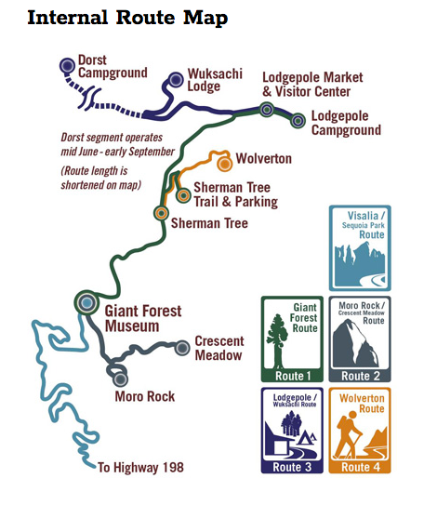

**Packing List**

Clothing

Underwear x 3

Socks x 3

Shorts x 1

Long hiking pants x 1

Long sleeve light shirt x 2

Short sleeve shirt x 1

Merino long sleeve x 1

Denim shirt x 1

Outerwear / personal gear

Big hat x 1

Down jacket x 1

Rain jacket x 1

Rain pants x ?

Gloves x 1

Bandana or buff x 1

Sunglasses x 2

Headlamp x 1

Charging pack + cord x 1

Toothbrush x 1

Lip balm x 1

Hiking boots x 1

Sandals x 1

Book x 1

Gear (Shared)

Camp suds x 1 bottle

First aid kit x 1

Sunscreen x 2 (Body and face)

Bug spray x 1

Bear spray x 1

Bear bell x 1

Compass / whistle x 1

Tarpaulin x 1

Bear vault x 1

Two-person tent x 1

Knife x 1

Mini lantern x 1

Camp stove x 1

Plate x 2

Bowl x 2

Mug x 2

Spork x 2

Deck of cards x 1

Ball or frisbee x 1

Map x 1

Trail itinerary document (this one!) x 2

Books to bring?

Never Cry Wolf, Farley Mowat

Hikers Bible, Robert Elman

Shantaram, Gregory David Roberts

The Indifferent Stars Above, Daniel James Brown

Law’s Field Guide to the Sierra Nevada

Sierra Nevada Natural History

Food plan:

<https://www.adventurealan.com/sample-7-day-food-list/>

<https://www.greenbelly.co/pages/5-day-ultralight-backpacking-meal-plan>

<https://www.theyummylife.com/Backpacking_Food>

<https://www.backpackingchef.com/backpacking-menu.html>